classroom work
———————
Import Extension in VS Code:
1) Open VS Code
2) File -->Open Folder --->Folder path of the extension
Load the extension to the brower
Chrome:
1)Extract the Zip file
2)Copy the path where manifest.json is present(Local file)
3)Open Chrome browser and type chrome://extensions or edge://extensions
4)Enable developer mode in the browser
5)Click on Load unpacked
6)Give the path copied in step -2
7)Extension Appears
8)Pin the extension
Generate script:
1)Set the Groq Key in settings
2) Click on inspect and select the DOM
3)CLick stop
4)Click on Generate button
What evere changes are done in manifest --Reload the extension

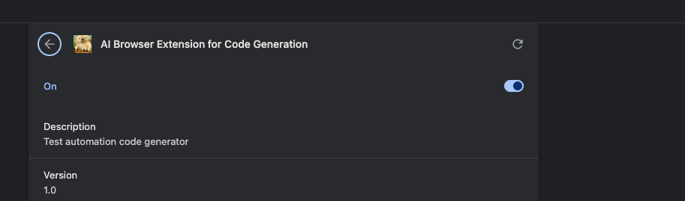

Feature: Login to OpenTaps

Scenario Outline: Successful login with valid credentials
Given I open the login page
When I type "<username>" into the Username field
And I type "<password>" into the Password field
And I click the Login button
Then I should be logged in successfully

Examples:
| username | password |
| "ramesh123" | "chennai123"|
| "sureshadmin" | "bangalore" |
| "kumaruser" | "hyderabad" |

Scenario Outline: Unsuccessful login with invalid credentials
Given I open the login page
When I type "<username>" into the Username field
And I type "<password>" into the Password field
And I click the Login button
Then I should see an error message

Examples:
| username | password |
| "invaliduser" | "wrongpass" |
| "wrongadmin" | "invalid123" |
| "test123" | "wrongpassword"|

Scenario: Login with empty credentials
Given I open the login page
When I click the Login button
Then I should see an error message

Scenario: Login with only username
Given I open the login page
When I type "suresh" into the Username field
And I click the Login button
Then I should see an error message

Scenario: Login with only password
Given I open the login page
When I type "mumbai123" into the Password field
And I click the Login button
Then I should see an error message
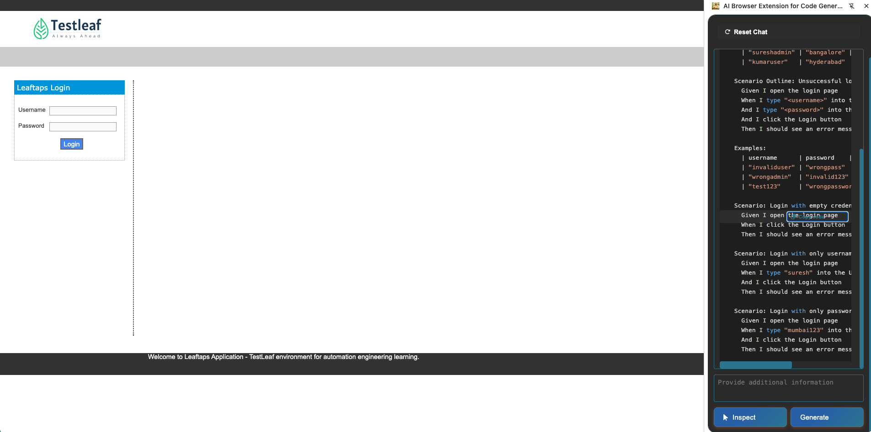

18/1/26
————
week3 day2
———————
classwork
——————
Steps:
1) Open your vscode and import the project (zip -> extract)
2) npm install (open terminal -> npm install)
3) Confirm node_modules are available at the root folder
4) go to .env and paste your groq api
5) go and run >> npm run dev

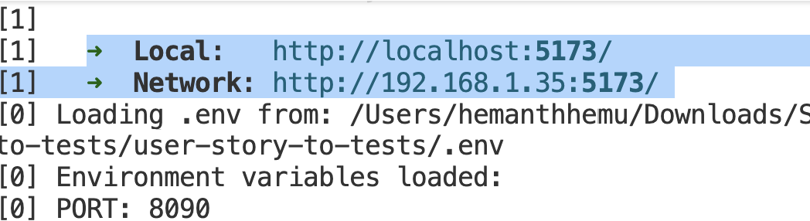
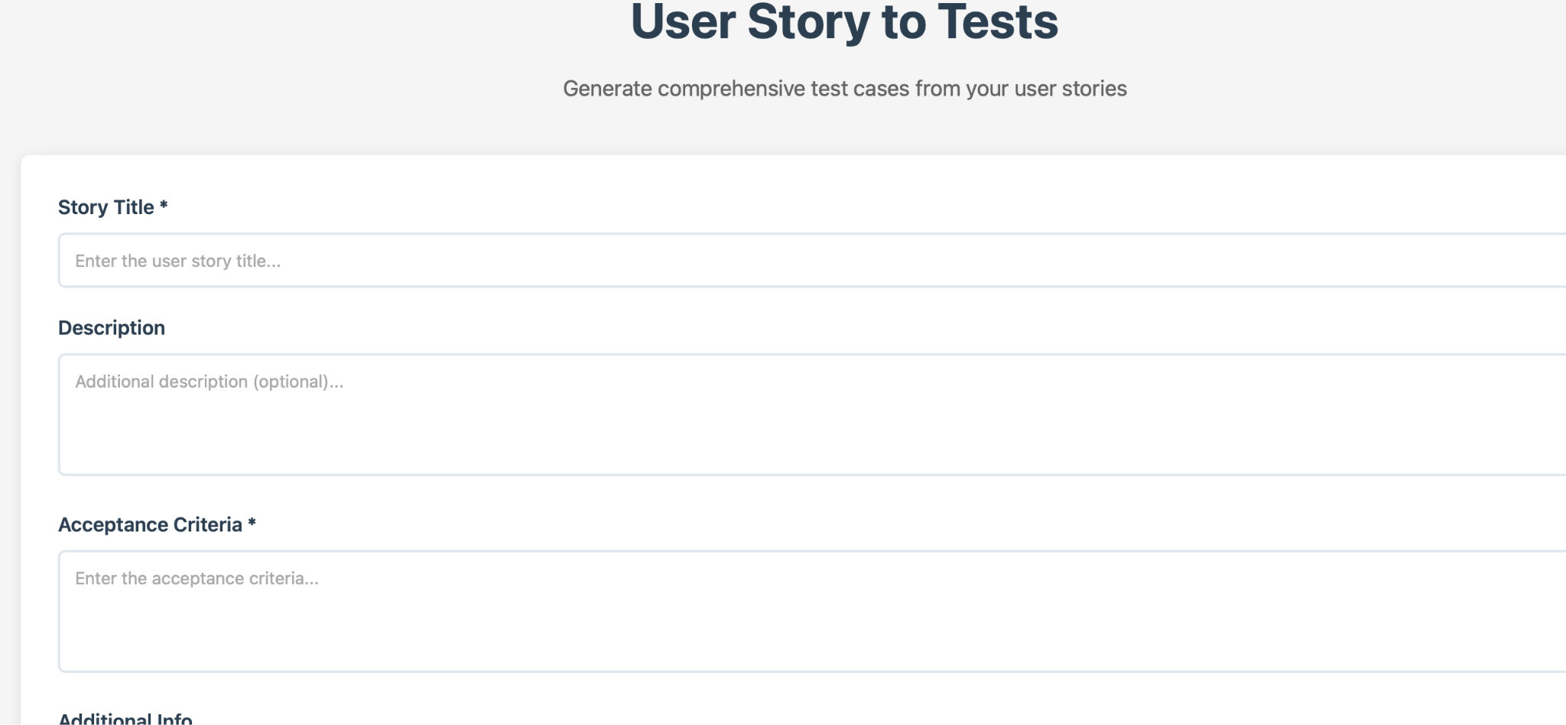

http://localhost:5173

